Name: S.GuruDeepika
Reg no: 192572108
Course:CSA1209 Computer Architecture

- To write an assembly language program to implement 16-bit division using 8085
processor.

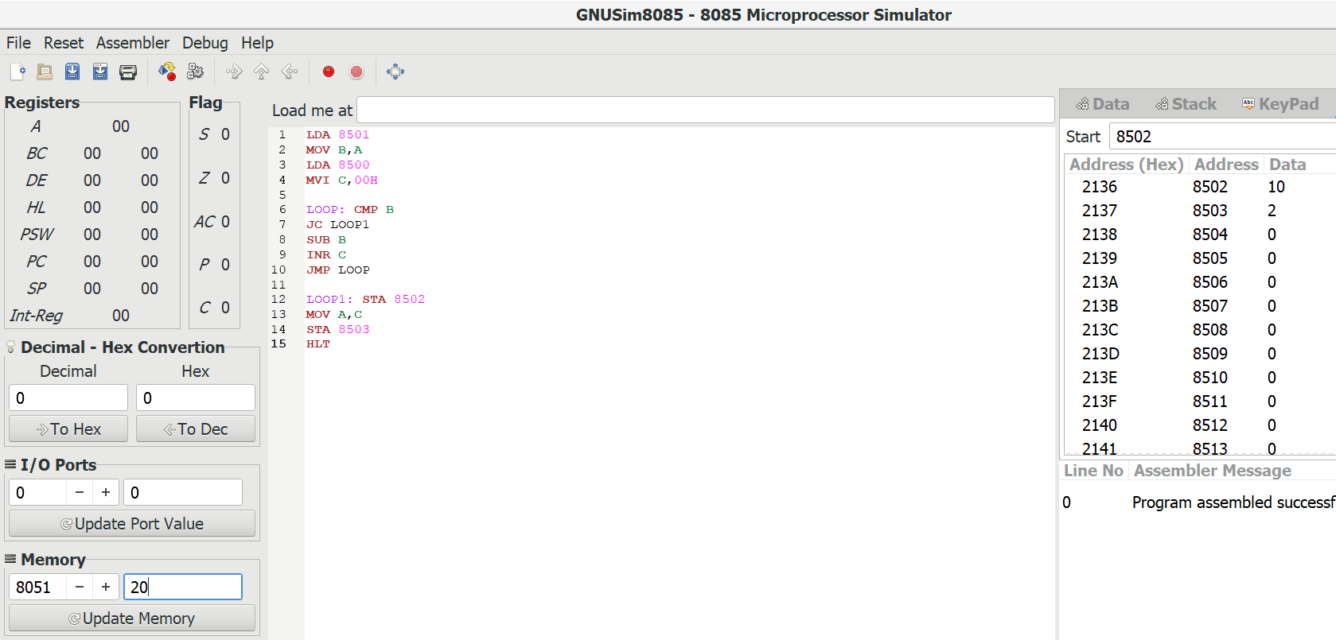

- To write an assembly language program to implement 16-Bit addition using 8086 processor.

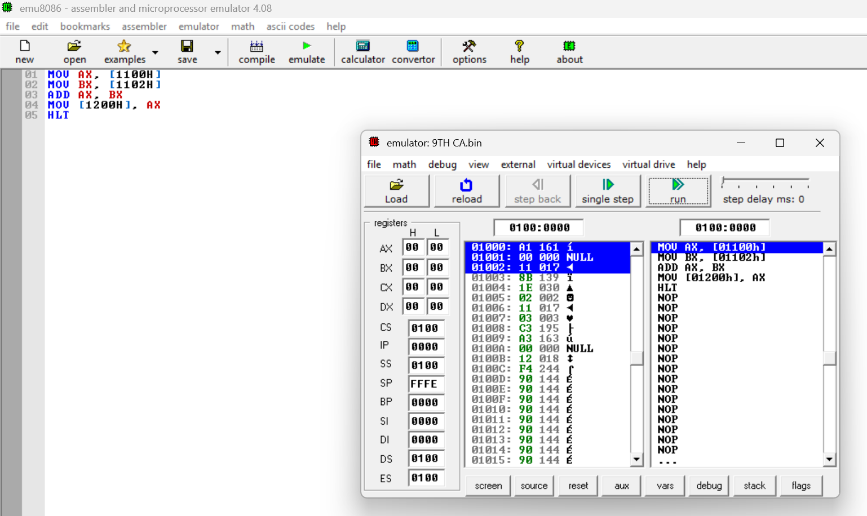

- To write an assembly language program to implement 16 bit subtraction using 8086 processor.

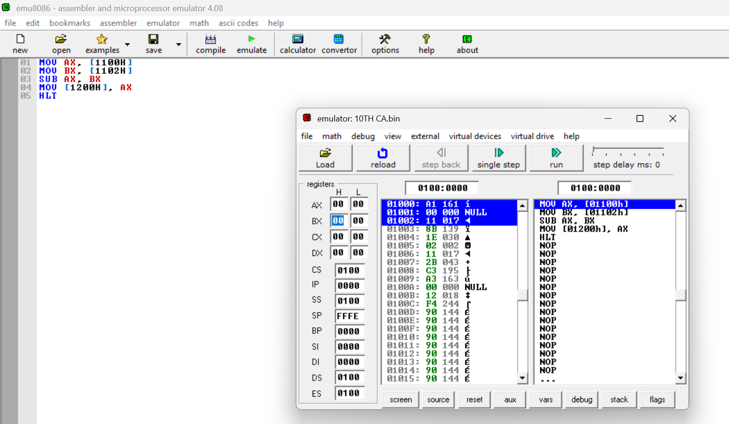

- To write an assembly language program to implement 16-bit multiplication on 8086 processer.

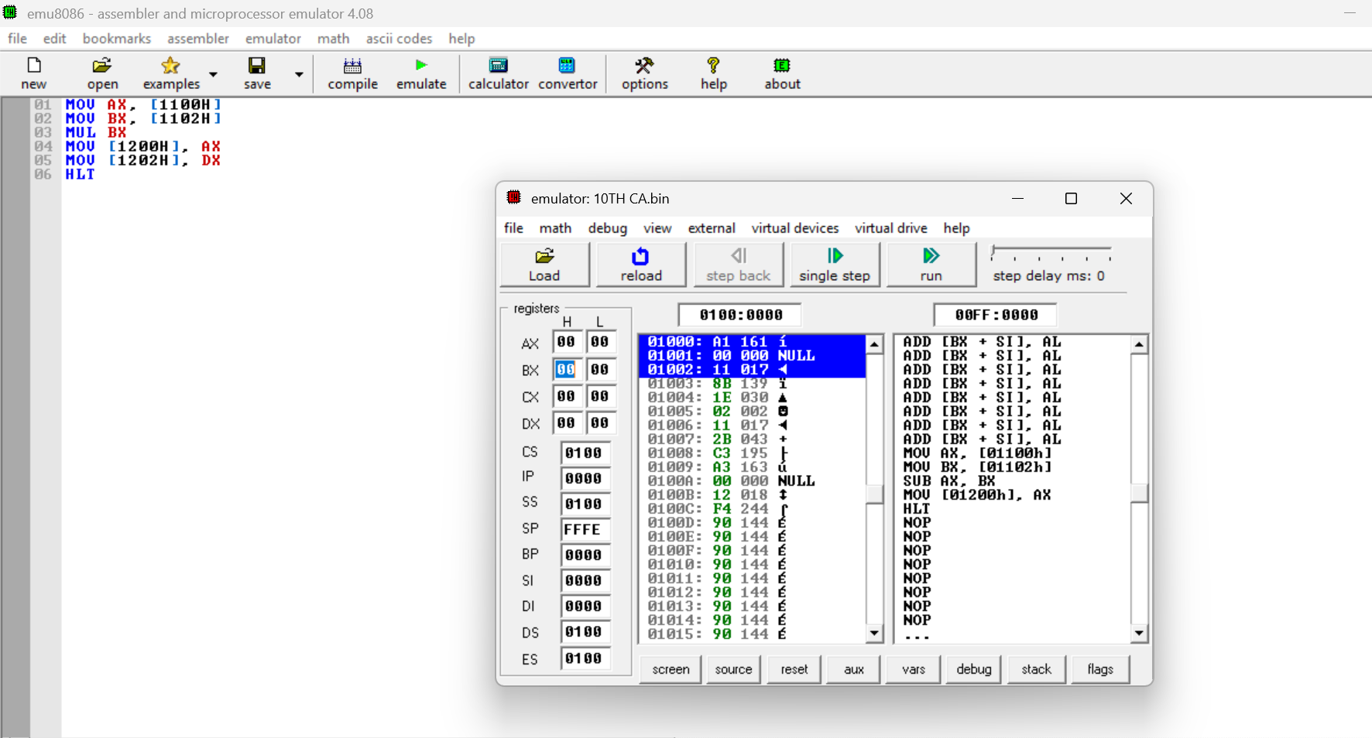

- To write an assemble language program to implement 16 bit divided using 8086 processor.

